Decades Paper
Your job is to predict what you will be doing in each Decade of your life.
When will you have kids? When will you buy your first car without your parents help?
When will you retire? When will you be working in your career of choice?
When will you get married? When will you hope to have grandchildren?
When will you buy your first house?
These are normal everyday experiences as an American citizen.
We have already completed a My List or Bucket List so this is not the place to dream about riding ostriches or jumping out of an airplane.
Below are listed the decades of your life. The years are also included with each decade.
Take a moment to look at the dates. Yes you will be alive in 2028.
Gentlemen you might be working on the “Slope” and ladies you might be soccer moms and working two jobs but what else will you be doing and what will you be hoping for at that age?
Now use the chart to transfer your decades to the boxes on the next two pages. (More years are listed on the last page).
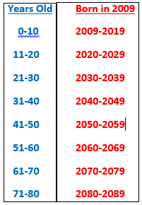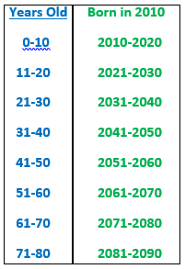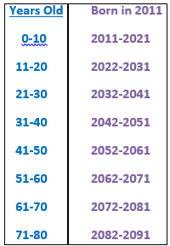

Make 3 predictions per decade as to what you will be doing.
Then ask one parent what they were doing during their Decades.
Your parents will also need to predict what they will be doing in their future decades as well.
Use a different color pen or pencil for your parent’s answers.

Ages 0-10 Ages 11-20
Years__________ Years __________

Ages 21-30 Ages 31-40
Years__________ Years__________

Ages 41-50 Ages 51-60
Years__________ Years__________

Ages 61-70 Ages 71-80
Years__________ Years__________

More Decades

Years Old Born in 2011
0-10 2011-2021
11-20 2022-2031
21-30 2032-2041
31-40 2042-2051
41-50 2052-2061
51-60 2062-2071
61-70 2072-2081
71-80 2082-2091

